**Oak Park School District**

Winter 2021

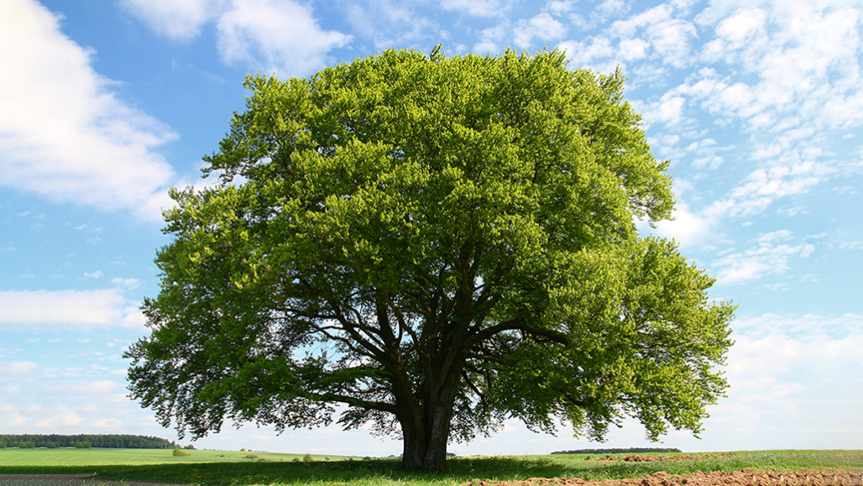

**Hoffman Planetarium**

*Kindergarten Activity Guide*

**Earth Science**

**Making Observations**

All good scientists make great observations. See how many of these items you can find by observing from where you are. Put a check in the box if you see the item.

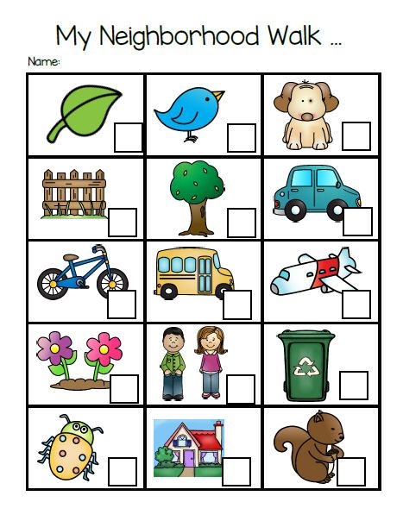

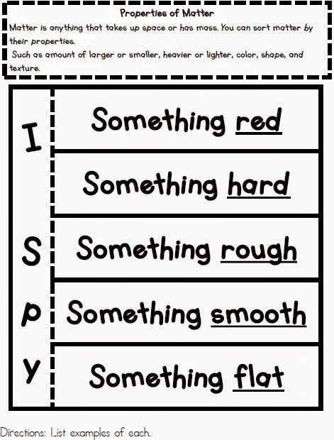

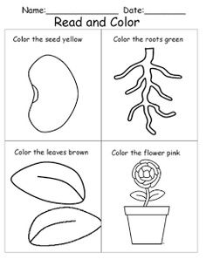

Find the items listed in the puzzle below.

1. Which items are made of wood?
2. 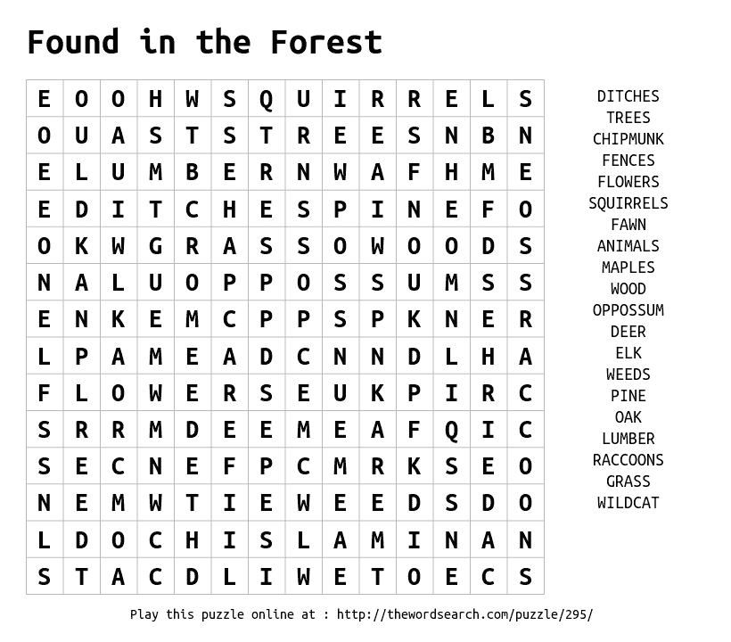How many are living?

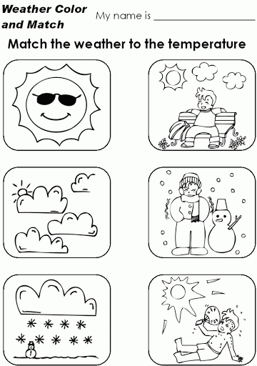

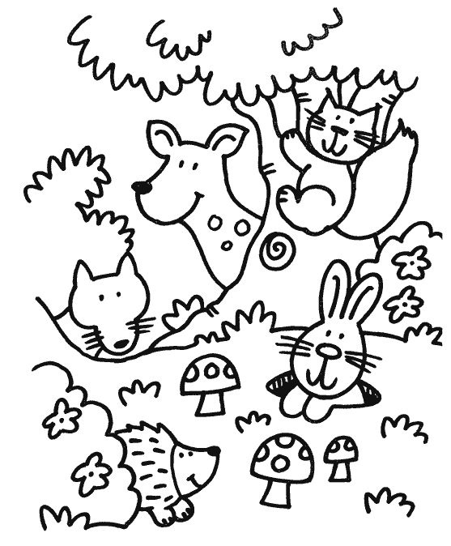

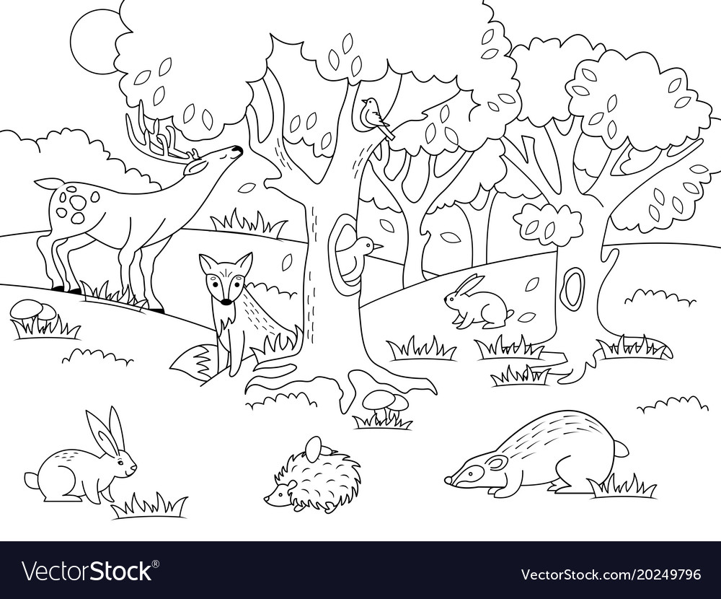**Forests**

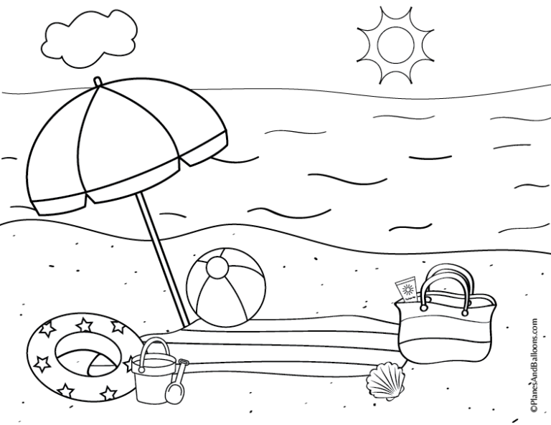

**Beaches**

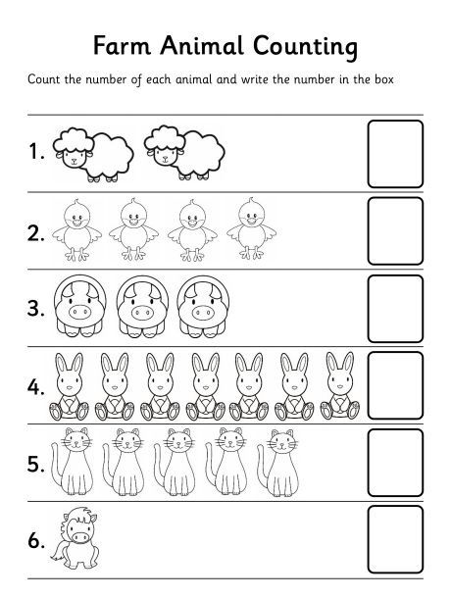

**Life Cycle of Plants**

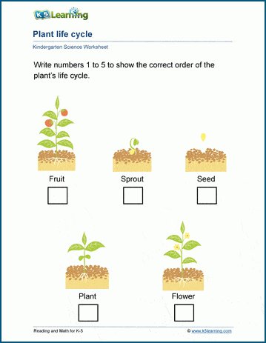

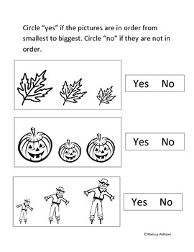**Color and circle “yes” if the pictures are in order from smallest to biggest. Circle “no” if they are not in order**.

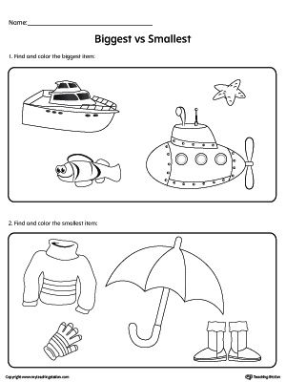**Number and color the pictures from smallest to largest (1 to 4)**

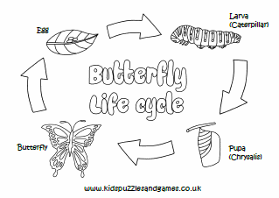**Label and color the life cycle below.**

