Title: What is the Sun’s Corona?
Student Sheet

- Background Knowledge: Long before there were cameras or telescopes, early scientists recorded what they saw in the sky in words, carvings, drawings, and paintings. While early observations of the night sky made valuable contributions to scientific discoveries, modern, advanced NASA equipment provides even more data about the Sun and the solar system.

- Analyze Images: Compare the images of the Sun below. For each image, describe what you see. What are the similarities and differences between the features in the Sun’s corona across the images? Add your observations to Data Table 1.

 | Image 1 | Image 2 | Image 3 | Image 4
Image | 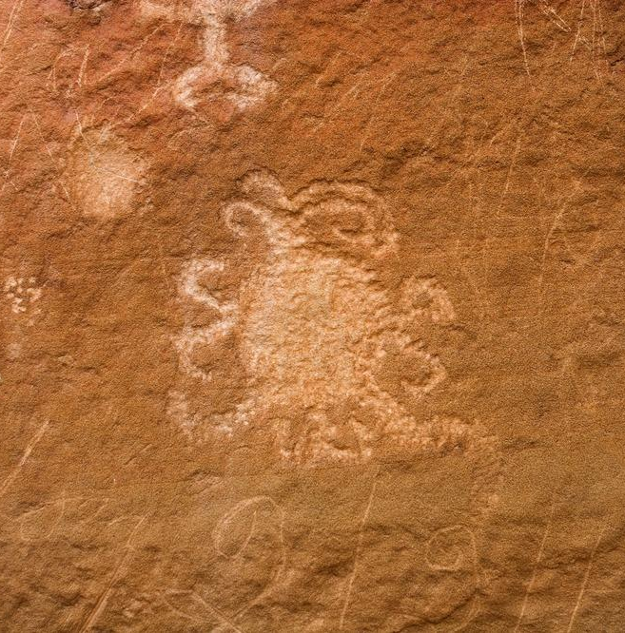  Credit: National Park Service | Credit: G. Tempel | Credit: NASA/ESA SOHO | 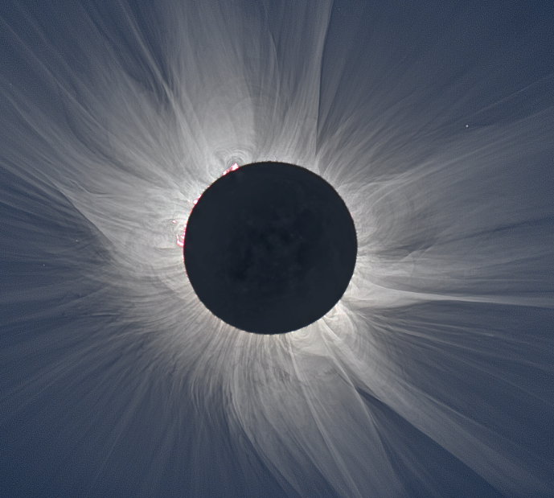  Credit: S. Habbel, M. Druckmüller, and P. Aniol
Observations

Similarities

Differences

- Some features of the Sun’s corona are only seen using special cameras and filters. Image 4 is a composite image, and not what you would see with your naked eye during a total solar eclipse. Examine the same image, in Figure 1, showing some of the coronal features that can be observed using special equipment.
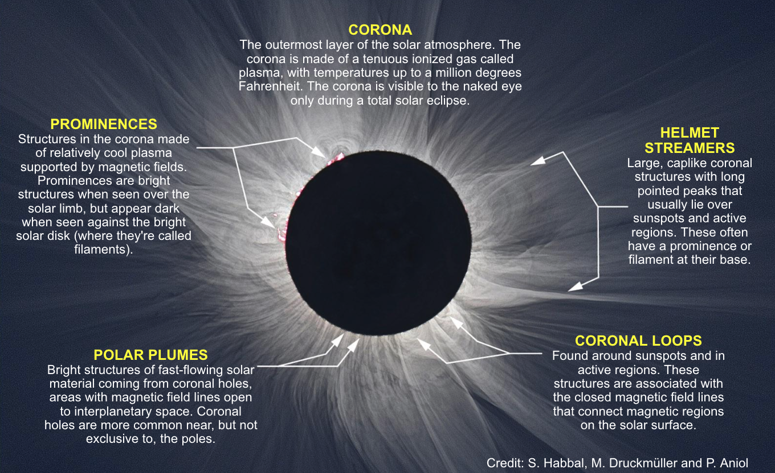
Figure 1: A highly processed NASA composite image showing some of the features of the Sun’s corona. Credit: S. Habbel, M. Druckmüller, and P. Aniol

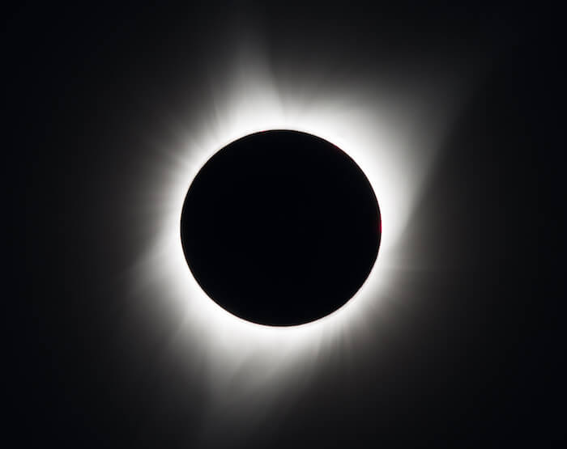
Image 5, below, is a more realistic depiction of what you would typically see during a total solar eclipse, at the moments of totality, with the naked eye. Remember that you need to use a solar filter, like solar eclipse glasses, to view the partial stages of the eclipse.

Image 5: Picture of a total solar eclipse using a simple solar filter on a telescope. This is what you would typically see during a total solar eclipse, in the moments of totality, with the naked eye. Credit: NASA/Aubrey Gemignani

  - Which features of the corona, labeled in figure 1, do you see in the image of a total solar eclipse (Image 5)? Label the Image 5 with features of the corona.

- Predict: Notice the coronal loops depicted in the carving from Chaco Canyon in 1097 (Image 1) and the drawing from 1860 (Image 2).
Image 1 Image 2

Solar features, like coronal loops, would be visible with the naked eye, if the total solar eclipse occurred during a period in the solar cycle called solar maximum.

The solar cycle is approximately 11 years, which occurs when the Sun’s magnetic poles switch. During solar maximum, the Sun is more active, producing solar eruptions that can be seen as loops and streamers in the corona. Scientists have been monitoring the solar cycle since the 1700’s and the next solar maximum is predicted for 2025. This means that features like coronal loops and helmet streamers may be visible during the April 8, 2024 total solar eclipse.

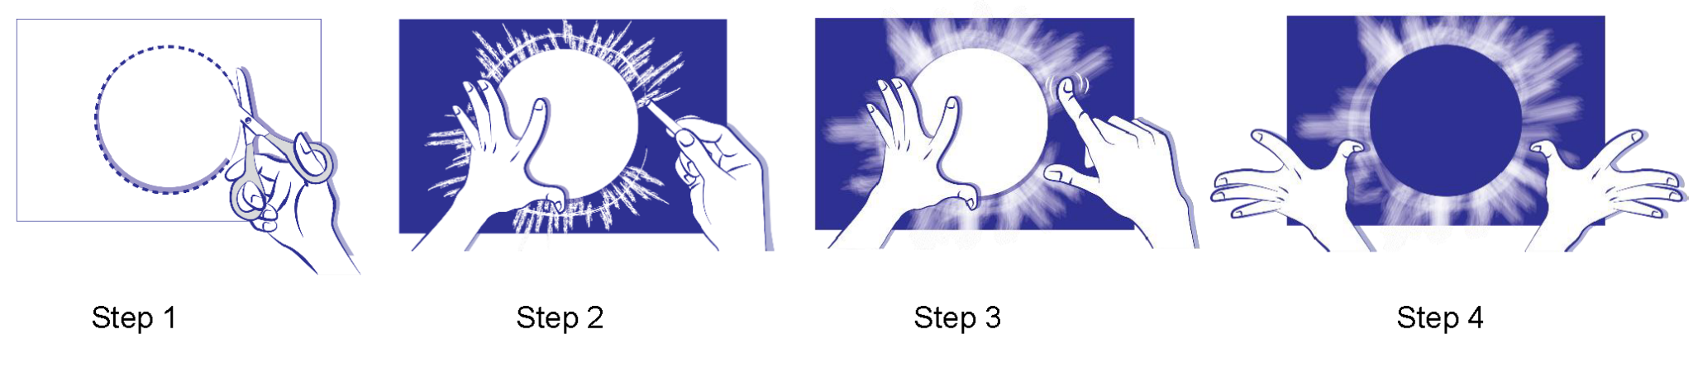
- Create a drawing for your prediction for what you may see during the April 8, 2024 total solar eclipse.

Steps for Creating a Corona Drawing, Credit: NASA GSFC/M.P. Hrybyk-Keith

- Step 1: Trace and cut a large circle template on stiff paper, like cardstock.
- Step 2: Place the template on dark paper and hold or tape it down. Draw a thick circle or lines of chalk around the template a few times.
- Step 3: Holding the template in place, smudge the chalk away from the center of the circle using a finger to create the corona of the Sun.
- Step 4: When you are done smudging the chalk, remove the template and label the coronal features that you may expect to see during the April 8, 2024 total solar eclipse.
- Save your prediction and compare it to your observations during the April 8, 2024 total solar eclipse across the US!

