Selma to Montgomery March

Workbook

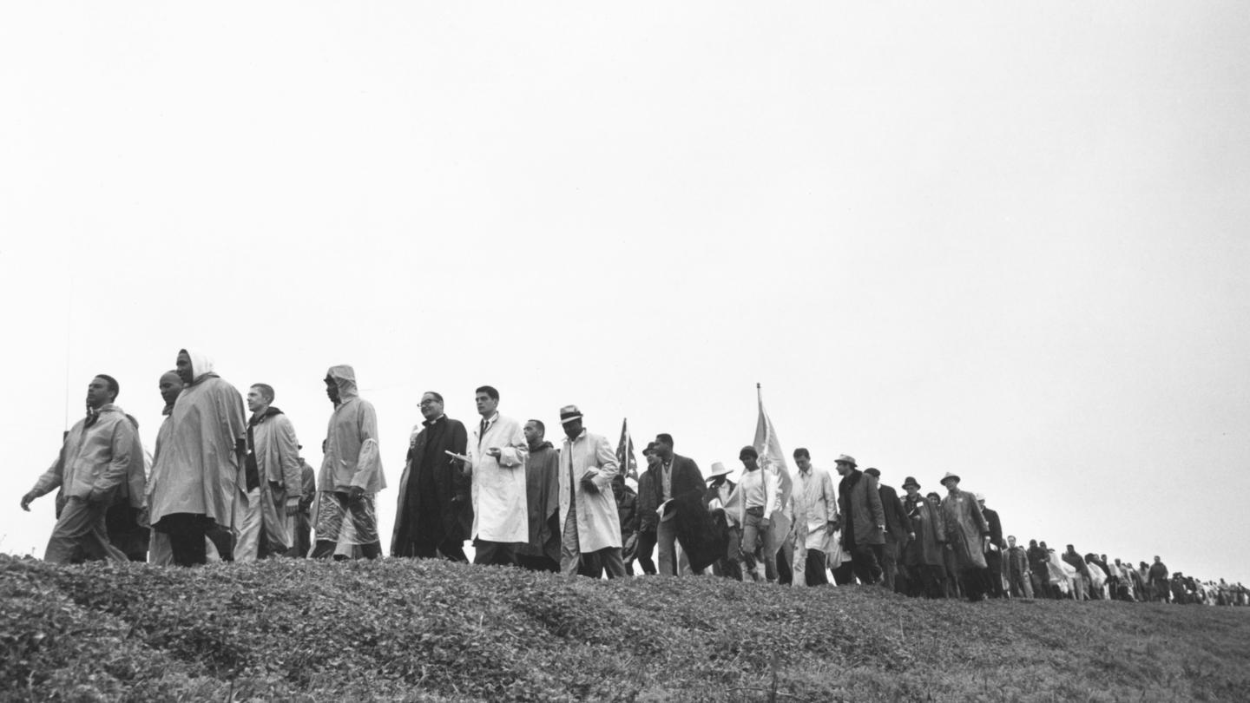
This workbook belongs to

Click or tap here to enter text.

Welcome to the Selma to Montgomery March tour!
In today’s workshop, we are going to be taking you on a scavenger hunt back in time! We will get to virtually explore the Jackson Home and learn about the people that made the Selma to Montgomery March a reality.

The Jackson Home was the official residence where world leaders resided while planning the monumental Selma to Montgomery March. Students will visit the home just as it was in 1965, and other historical points as they take the virtual walk from Selma to Montgomery.

We put together this handy workbook to guide your great hunt. In the following pages, you will find space for all the questions and tasks that you will come across during your scavenger hunt. Do not hesitate to ask any questions you might have along the way – and make sure you have a great time!

Let the Hunt Begin!

Table of Contents
Welcome to the Selma to Montgomery March tour! 2
Helpful tools and tips 4
PART ONE: AREA DISCOVERY! 6
PART TWO: PHOTO HUNT! 8
PART THREE: MY EXPERIENCE! 13

Helpful tools and tips
Below is a list of helpful tools and features that will make your great hunt a little easier.
Windows 10

Taking a screenshot
- Press Windows logo key + Shift + S to bring up the Snip and Sketch tool.
- Drag to outline the part of your screen you want to capture. To capture the entire screen, click the icon to the left of the “X.” To cancel the screen capture, press the Escape (Esc) key.
- In the window where you want to place the screen capture, press Ctrl + V to paste the image.

Seeing two windows at once
- Select the title bar of the window you want to snap.
- Drag it to the edge of your screen. An outline will appear to show where the window will snap to once you drop it.
- Drag it to the left or right side of your screen to snap it to the left or right half of the screen.
- If other windows are open, you can select one to fill the other half of the screen.
MacOS

Taking a screenshot
- Press Shift + Command + 4 and drag to outline the part of your screen you want to capture. To capture the entire screen, press Shift + Command + 3. To cancel the screen capture, press the Escape (Esc) key.
- If you see a thumbnail in the corner of your screen, click it to edit the screenshot. Or wait for the screenshot to save to your desktop.

Seeing two windows at once
If the steps below don't work, choose Apple menu > System Preferences, click Mission Control, and make sure that “Displays have separate spaces” is selected.
Method 1: MacOS Catalina
- Hover your pointer over the full-screen button in the upper-left corner of a window.
- Choose ”Tile Window to Left of Screen” or ”Tile Window to Right of Screen” from the menu.
Method 2: Older MacOS versions
- Click and hold the full-screen button in the upper-left corner of a window.
- As you hold the button, the window shrinks, and you can drag it to the left or right side of the screen.
- Release the button, then click a window on the other side of the screen to see both windows side by side.

PART ONE: AREA DISCOVERY!
In Area Discovery, you will need a good eye and some great virtual field trip skills to answer three trivia questions in each area. Follow along and pay attention to the text and videos to find the answers. The Teacher for the day will share Location Hints that will help guide you to the answer locations, so be sure to listen as you are exploring!

Click here to explore the Jackson Home
https://aka.ms/SelmaToMontgomeryMarch

Question 1
What was the name of the kitchen in the Jackson Home where Martin Luther King Jr., Dr. Ralph Brunch, Congressman John Lewis and Andrew Young (among others) used as their headquarters?

Answer here!  Click or tap here to enter text. | Location hint!  Kitchen frame

Question 2
Who was the first African American to ever win a Nobel Peace Prize?

Answer here!  Click or tap here to enter text. | Location hint!  Dining room

Question 3
Who delivered the “We shall overcome” speech that Martin Luther King Jr. was moved by?

Answer here!  Click or tap here to enter text. | Location hint!  Living Room Chair

Question 4
What was the name of the rabbi who stayed at the Jackson Home to give advice to Dr. Martin Luther King Jr.?

Answer here!  Click or tap here to enter text. | Location hint!  Living Room - Photo

Question 5
In what room did Martin Luther King Jr. have many phone calls with President Lyndon B. Johnson to discuss equality and how to achieve a democratic society for all?

Answer here!  Click or tap here to enter text. | Location hint!  A phone is highlighted on the video

Question 6
Martin Luther King Jr. met with his most trusted lieutenants in ____ parent’s room in the morning the _______ ___ ___________ March would take place to pray and prepare for what was to come ahead.

Answer here!  Click or tap here to enter text. | Location hint!  Parent’s bedroom

Question 7
On October 7th, 1963, why were 350 African Americans gathered in front of the Dallas County Courthouse?

Answer here!  Click or tap here to enter text. | Location hint!  Dallas County Courthouse

Question 8
On Feb. 1st, 1965, Dr. King and Ralph Abernathy lead a protest about refuse to do what 2 things that day?

Answer here!  Click or tap here to enter text. | Location hint!  Selma Police Station

Question 9
Why did Dr. King and several other Civil Rights protestors wear Hawaiian flower leis?

Answer here!  Click or tap here to enter text. | Location hint!  Welcome to Historic Selma sign in front of Edmund Pettus Bridge

Question 10
Sunday, March 7, 1965 was the first major day in the Selma-to-Montgomery March timeline and will forever be known as what?

Answer here!  Click or tap here to enter text. | Location hint!  Edmund Pettus Bridge

Question 11
What did Dr. King peacefully do on the Edmund Pettus Bridge on Tuesday, March 9^{th,} 1965 before turning around to lead everyone back to Brown Chapel?

Answer here!  Click or tap here to enter text. | Location hint!  Edmund Pettus Bridge

Question 12
How many people walked in the Selma-to-Montgomery March, led by Dr. King on March 21st, 1965?

Answer here!  Click or tap here to enter text. | Location hint!  Brown Chapel

Question 13
What was the mission of the Southern Christian Leadership Conference (SCLC)?

Answer here!  Click or tap here to enter text. | Location hint!  Brown Chapel

Question 14
How did “Tent City” come to be and what purposes did it serve?

Answer here!  Click or tap here to enter text. | Location hint!  Tent City

Question 15
What legendary musical artists performed at what is now known as the “Stars of Freedom” rally?

Answer here!  Click or tap here to enter text. | Location hint!  City of St. Jude

PART TWO: MY EXPERIENCE
Here’s your opportunity to do some free exploring and tell us all about your favorite section of the Selma to Montgomery March Experience. Share which part of the experience resonated with you the most and why.

Which part of the experience made you reflect on the history of the Civil Rights Movement the most?

Why do you think this part of the experience resonated with you the most?
What else did you learn today that made a significant impact on you and why?

Take screenshots of some of the images from the virtual tour that stood out to you the most, and insert/paste below:

