National Center for Civil and Human Rights Workbook

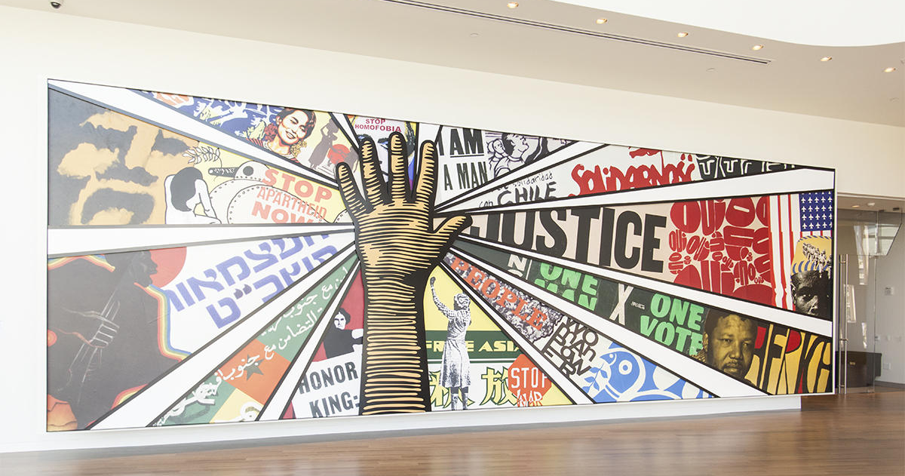
This workbook belongs to:

Click or tap here to enter text.

Welcome to the National Center for Civil and Human Rights virtual tour!
In today’s workshop, we’re going to be taking you on a scavenger hunt back in time! We’ll get to virtually explore the National Center for Civil and Human Rights museum and the many faces that fought for justice!

The National Center for Civil and Human Rights is a museum and cultural institution that connects the U.S. Civil Rights Movement to human rights challenges today.
Students will visit immersive virtual exhibits and view original documents from Dr. Martin Luther King Jr.'s civil rights work and learn the history of the U.S. Civil Rights Movement.

We’ve put together this handy workbook to guide your exploration. In the following pages, you’ll find space for all the questions and tasks that you’ll come across during your scavenger hunt. Don’t hesitate to ask any questions you might have along the way – and make sure you have a great time!

Let the Adventure Begin!

Table of Contents
Welcome to the National Center for Civil and Human Rights virtual tour! 2
Helpful tools and tips 4
PART ONE: ZONE DISCOVERY! 6
PART TWO: MY EXPERIENCE 8

Helpful tools and tips
Below is a list of helpful tools and features that will make your great hunt a little easier.
Windows 10

Taking a screenshot
- Press Windows logo key + Shift + S to bring up the Snip and Sketch tool.
- Drag to outline the part of your screen you want to capture. To capture the entire screen, click the icon to the left of the “X.” To cancel the screen capture, press the Escape (Esc) key.
- In the window where you want to place the screen capture, press Ctrl + V to paste the image.

Seeing two windows at once
- Select the title bar of the window you want to snap.
- Drag it to the edge of your screen. An outline will appear to show where the window will snap to once you drop it.
- Drag it to the left or right side of your screen to snap it to the left or right half of the screen.
- If other windows are open, you can select one to fill the other half of the screen.
MacOS

Taking a screenshot
- Press Shift + Command + 4 and drag to outline the part of your screen you want to capture. To capture the entire screen, press Shift + Command + 3. To cancel the screen capture, press the Escape (Esc) key.
- If you see a thumbnail in the corner of your screen, click it to edit the screenshot. Or wait for the screenshot to save to your desktop.

Seeing two windows at once
If the steps below don't work, choose Apple menu > System Preferences, click Mission Control, and make sure that “Displays have separate spaces” is selected.
Method 1: MacOS Catalina
- Hover your pointer over the full-screen button in the upper-left corner of a window.
- Choose ”Tile Window to Left of Screen” or ”Tile Window to Right of Screen” from the menu.
Method 2: Older MacOS versions
- Click and hold the full-screen button in the upper-left corner of a window.
- As you hold the button, the window shrinks, and you can drag it to the left or right side of the screen.
- Release the button, then click a window on the other side of the screen to see both windows side by side.

PART ONE: ZONE DISCOVERY!
In Zone Discovery, you’ll need a good eye and some great virtual field trip skills to answer 3 trivia questions in each area. Follow along and pay attention to the text and videos to find the answers. The Teacher for the day will share Location Hints that will help guide you to the answer locations, so be sure to listen as you’re exploring!

Click Here to explore the National Center for Civil Rights Museum

Zone 1: Rolls Down Like Water | Segregationists [3 min]

Question 1
When you watched the video about Bull Connor and how the police disrupted the peaceful protest of African Americans. What surprised you about this video?
Answer here!  Click or tap here to enter text. | Location hint!  Segregationists Exhibit

Question 2
Strom Thurmond made the longest filibuster ever in an unsuccessful attempt to derail the passage of the ________________ of 1957:
Answer here!  Click or tap here to enter text. | Location hint!  Segregationist Exhibit

Zone 2 – Jim Crow Laws | Brown vs. Board of Education [10 minutes]

Question 3
How did “Jim Crow Laws” affect Education?
Answer here!  Click or tap here to enter text. | Location hint!  Jim Crow Laws Exhibit

Question 4
In the case Brown Vs Board, we learn how separating black kids and white kids in schools created problems psychologically and morally for both. How would you feel if that were normal today?
Answer here!  Click or tap here to enter text. | Location hint!  Brown VS Board Video

Zone 3 - A Movement Catches Fire – [10 minutes]

Question 5
The late Great John Lewis who we will learn about a little later once stated that ‘Emmett Till was my George Floyd. Pause and reflect on both cases almost 70 years apart. Do you see any similarities? What do you think John Lewis meant?
Answer here!  Click or tap here to enter text. | Location hint!  Zone 3 – What’s your opinion?

Zone 4- March on Washington – [10 minutes]

Question 6
When you hear those words does it sound like something 60 years ago or something today? DO you think America is at a point where African Americans are judged by their character and not their color? Are we really all equal?
Answer here!  Click or tap here to enter text. | Location hint!  Zone 4 – March on Washington

Zone 5 – New-Era of the Civil Rights Movement [10 minutes]
Question 7
What were the names of the four young girls?
Answer here!  Click or tap here to enter text. | Location hint!  Church Windows

Zone 6: Civil Rights Martyrs – [10 minutes]
Question 8
What was the story that impacted you most of the countless African Americans who lost their lives during the modern Civil Rights Movement?
Answer here!  Click or tap here to enter text. | Location hint!  Martyrs Exhibit – Personal Opinion

PART TWO: MY EXPERIENCE
Here’s your opportunity to do some free exploring and tell us all about your favorite section of the Friends of Tuskegee Airmen Museum. Did you find any awesome fun facts or great images to share? We want to know why you loved it! (Scroll down)

What did you love the most?

Why did you love it?

