Muhammad Ali Museum

Workbook

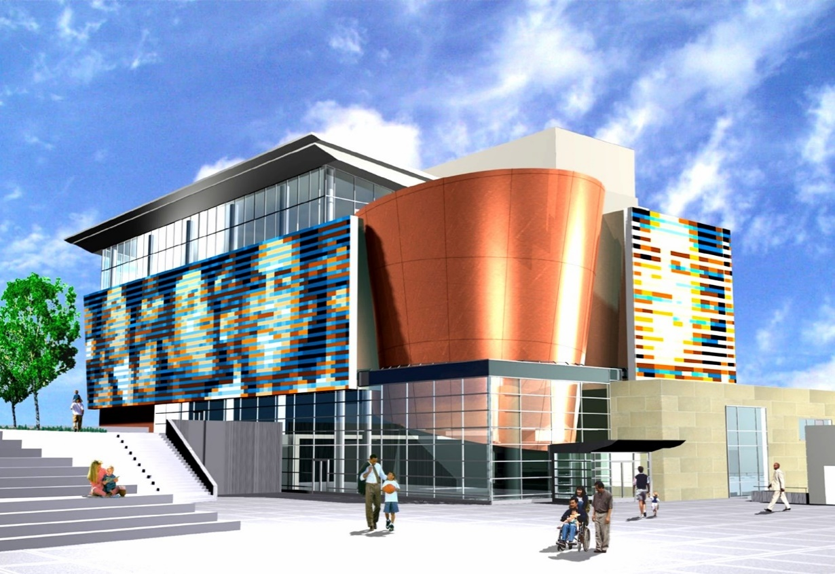
This workbook belongs to

Click or tap here to enter text.

Welcome to the Muhammad Ali Museum tour!
In today’s workshop, we are going to be taking you on a scavenger hunt back in time!

The Muhammad Ali Center celebrates the life of boxer and civil rights activist,
Muhammad Ali. Students will learn about Ali's life of activism, his legacy, and make a pledge to do better.

We put together this handy workbook to guide your great hunt. In the following pages, you will find space for all the questions and tasks that you will come across during your scavenger hunt. Do not hesitate to ask any questions you might have along the way – and make sure you have a great time!

Let the Hunt Begin!

Table of Contents
Welcome to the Muhammad Ali Museum tour! 2
Helpful tools and tips 4
PART ONE: AREA DISCOVERY! 6
PART TWO: MY EXPERIENCE! 9

Helpful tools and tips
Below is a list of helpful tools and features that will make your great hunt a little easier.
Windows 10

Taking a screenshot
- Press Windows logo key + Shift + S to bring up the Snip and Sketch tool.
- Drag to outline the part of your screen you want to capture. To capture the entire screen, click the icon to the left of the “X.” To cancel the screen capture, press the Escape (Esc) key.
- In the window where you want to place the screen capture, press Ctrl + V to paste the image.

Seeing two windows at once
- Select the title bar of the window you want to snap.
- Drag it to the edge of your screen. An outline will appear to show where the window will snap to once you drop it.
- Drag it to the left or right side of your screen to snap it to the left or right half of the screen.
- If other windows are open, you can select one to fill the other half of the screen.
MacOS

Taking a screenshot
- Press Shift + Command + 4 and drag to outline the part of your screen you want to capture. To capture the entire screen, press Shift + Command + 3. To cancel the screen capture, press the Escape (Esc) key.
- If you see a thumbnail in the corner of your screen, click it to edit the screenshot. Or wait for the screenshot to save to your desktop.

Seeing two windows at once
If the steps below don't work, choose Apple menu > System Preferences, click Mission Control, and make sure that “Displays have separate spaces” is selected.
Method 1: MacOS Catalina
- Hover your pointer over the full-screen button in the upper-left corner of a window.
- Choose ”Tile Window to Left of Screen” or ”Tile Window to Right of Screen” from the menu.
Method 2: Older MacOS versions
- Click and hold the full-screen button in the upper-left corner of a window.
- As you hold the button, the window shrinks, and you can drag it to the left or right side of the screen.
- Release the button, then click a window on the other side of the screen to see both windows side by side.

PART ONE: AREA DISCOVERY!
In Area Discovery, you will need a good eye and some great virtual field trip skills to answer three trivia questions in each area. Follow along and pay attention to the text and videos to find the answers. The Teacher for the day will share Location Hints that will help guide you to the answer locations, so be sure to listen as you are exploring!

Click Here to Explore the Muhammad Ali Museum
Question 1
Muhammad Ali was a great boxer, athlete and humanitarian but he was also one of the greatest _________ of all time

Answer here!  Click or tap here to enter text. | Location hint!  Wall of fame Video 0:41

Question 2
What were Ali’s 6 core principles and why do you think he chose to live by these?

Answer here!  Click or tap here to enter text. | Location hint!  6 core Principles video

Question 3
Write one CODE slaves had to obey/follow:

Answer here!  Click or tap here to enter text. | Location hint!  Slavery Graffiti Wall Exhibit (6 codes highlighted)

Question 4
What did the Civil Rights Act of 1964 help with?

Answer here!  Click or tap here to enter text. | Location hint!  Jim Crow Laws & Civil Rights Exhibit

Question 5
Name the heroic American figure that was assassinated during the time that Muhamad Ali fought for racial injustices

Answer here!  Click or tap here to enter text. | Location hint!  Jim Crow Laws & Civil Rights Exhibit

Question 6
1 in _ Black men are incarcerated compared to 1 in ___ white men.

Answer here!  Click or tap here to enter text. | Location hint!  Criminal Justice Graffiti Wall Exhibit

Question 7
How long was the Tuskegee Experiment supposed to last? How long did it actually last?

Answer here!  Click or tap here to enter text. | Location hint!  Video Healthcare Graffiti Wall Exhibit

Question 8
What is the name of the program that was designed to increase, and segregate Housing in America called?

Answer here!  Click or tap here to enter text. | Location hint!  Video Housing Graffiti Wall Exhibit

Question 9
Slaves couldn’t legally marry until slavery ended in the year _______

Answer here!  Click or tap here to enter text. | Location hint!  Housing and Family Wall Exhibit

Question 10
What were the names of the two characters that the entertainment industry used to perpetuate negative stereotypes of Black people?

Answer here!  Click or tap here to enter text. | Location hint!  Video Media Graffiti Wall Exhibit

Question 11
What movie/film criminalized Black People by presenting them as savages (among other terms)?

Answer here!  Click or tap here to enter text. | Location hint!  Media Graffiti Wall Exhibit

Question 12
Students of color receive _____ less in education funding than predominately White School districts

Answer here!  Click or tap here to enter text. | Location hint!  Wealth Gap and Education wall

Question 13
In 2014, what was the median household net worth for blacks who graduated college compared to whites?

Answer here!  Click or tap here to enter text. | Location hint!  Wealth Gap and Education wall

PART TWO: MY EXPERIENCE!
Here’s your opportunity to do some free exploring and tell us all about your favorite section of the Muhammad Ali Museum Experience. Did you find anything that impacted you? We want to know about what you learned.

What impacted you the most?

Why did it impact you?

