Friends of Tuskegee Airmen

Workbook

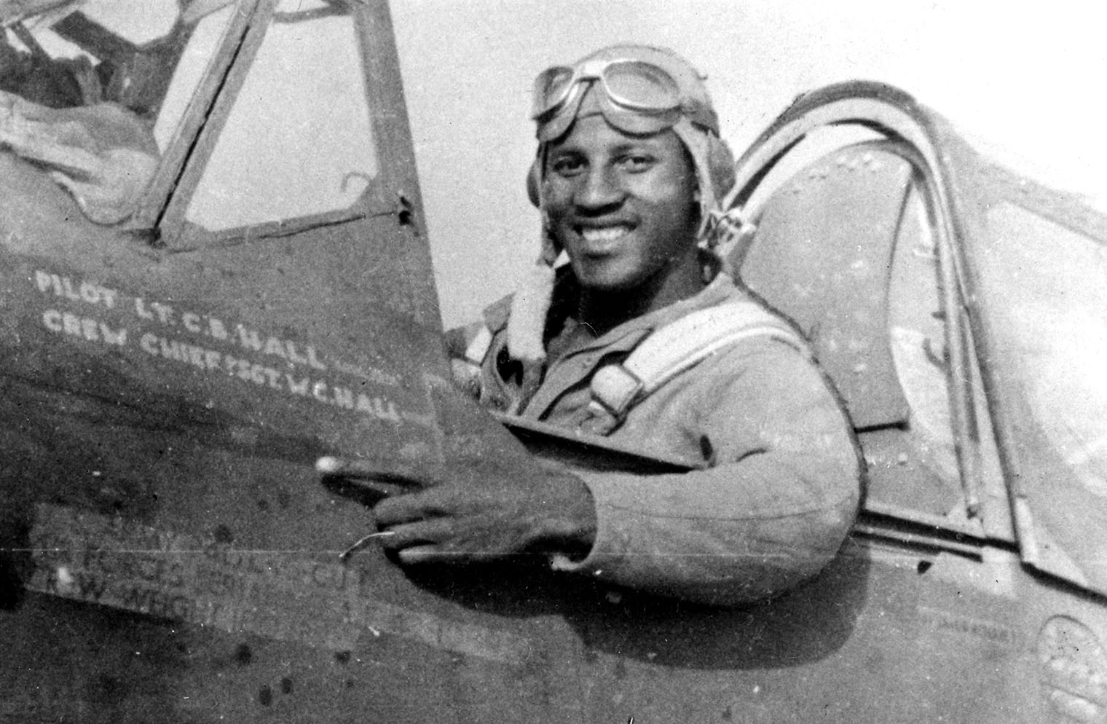
This workbook belongs to:

Click or tap here to enter text.

Welcome to the Friends of Tuskegee Airmen virtual tour!
In today’s workshop, we’re going to be taking you on a scavenger hunt back in time! We’ll get to virtually explore the Friends of Tuskegee Airmen lives and how they came to serve their country.

The Friends of Tuskegee Airmen National Historic Site honors the first African American military aviators in the United States Armed Forces. Today, you will learn about the struggles faced as they dealt with discrimination, segregation, and Jim Crow laws while completing their duty as military pilots.

We put together this handy workbook to guide your exploration. In the following pages, you’ll find space for all the questions and tasks that you’ll come across during your scavenger hunt. Don’t hesitate to ask any questions you might have along the way – and make sure you have a great time!

Let the Adventure Begin!

Table of Contents
Welcome to the Friends of Tuskegee Airmen Virtual tour! 2
Helpful tools and tips 4
PART ONE: AREA DISCOVERY! 6
Hangar 1 | Area 1 6
Hangar 1 | Area 2 7
Hangar 2 | Area 1 8
PART TWO: HANGAR 2 | PHOTO HUNT! 9
PART THREE: MY EXPERIENCE! 14

Helpful tools and tips
Below is a list of helpful tools and features that will make your exploration a little easier.
Windows 10

Taking a screenshot
- Press Windows logo key + Shift + S to bring up the Snip and Sketch tool.
- Drag to outline the part of your screen you want to capture. To capture the entire screen, click the icon to the left of the “X.” To cancel the screen capture, press the Escape (Esc) key.
- In the window where you want to place the screen capture, press Ctrl + V to paste the image.

Seeing two windows at once
- Select the title bar of the window you want to snap.
- Drag it to the edge of your screen. An outline will appear to show where the window will snap to once you drop it.
- Drag it to the left or right side of your screen to snap it to the left or right half of the screen.
- If other windows are open, you can select one to fill the other half of the screen.
MacOS

Taking a screenshot
- Press Shift + Command + 4 and drag to outline the part of your screen you want to capture. To capture the entire screen, press Shift + Command + 3. To cancel the screen capture, press the Escape (Esc) key.
- If you see a thumbnail in the corner of your screen, click it to edit the screenshot. Or wait for the screenshot to save to your desktop.

Seeing two windows at once
If the steps below don't work, choose Apple menu > System Preferences, click Mission Control, and make sure that “Displays have separate spaces” is selected.
Method 1: MacOS Catalina
- Hover your pointer over the full-screen button in the upper-left corner of a window.
- Choose ”Tile Window to Left of Screen” or ”Tile Window to Right of Screen” from the menu.
Method 2: Older MacOS versions
- Click and hold the full-screen button in the upper-left corner of a window.
- As you hold the button, the window shrinks and you can drag it to the left or right side of the screen.
- Release the button, then click a window on the other side of the screen to see both windows side by side.

PART ONE: AREA DISCOVERY!
In Zone Discovery, you’ll need a good eye and some great virtual field trip skills to answer 3 trivia questions in each area. Follow along and pay attention to the text and videos to find the answers. The Teacher for the day will share Location Hints that will help guide you to the answer locations, so be sure to listen as you’re exploring!

Discovery Section A: Hangar 1 | Area 1
Click here to explore the first hangar of the Tuskegee Airmen

Question 1
When was the Tuskegee Institute selected as the sole primary flying school for African Americans?

Answer here!  Click or tap here to enter text. | Location hint!  On to War exhibit

Question 2
What was the name of the practice that reinforced a system of racial separation and restriction for African Americans?

Answer here!  Click or tap here to enter text. | Location hint!  Confronting Jim Crow exhibit

Question 3
What kind of building did the Tuskegee Institute start out as in the beginning?

Answer here!  Click or tap here to enter text. | Location hint!  Where They Trained exhibit

Discovery Section B: Hangar 1 | Area 2
Question 4
Who was the director of Mechanical Industries at Tuskegee Institute?

Answer here!  Click or tap here to enter text. | Location hint!  Civilian & Military Stuff Exhibit

Question 5
In _______ Lewis A. Jackson became director of Tuskegee’s Institute’s military and civilian flight training programs.
- 1932
- 1939
- 1941

Answer here!  Click or tap here to enter text. | Location hint!  Civilian & Military Staff Exhibit

Question 6
What’s the 5-digit number on the yellow NC 2 airplane?

Answer here!  Click or tap here to enter text. | Location hint!  Go to the yellow NC 2 plane

Discovery Section C: Hangar 2 | Area 1
Click Here to explore the second hangar of the Tuskegee Airmen

Question 7
What does the “Double V” Motto stand for?

Answer here!  Click or tap here to enter text. | Location hint!  Double V Exhibit (Blue Wall)

Question 8
How long did the Tuskegee Airmen have to wait to be deployed, compared to white units?

Answer here!  Click or tap here to enter text. | Location hint!  Second Double V Exhibit (White and Blue wall)

Question 9
African Americans threatened to march on Washington D.C. to demand better work opportunities. As a result, President Franklin D. Roosevelt signed Executive Order #__________, opening government and defense contract work to all people, “regardless of race, creed, color or national origin.”

Answer here!  Click or tap here to enter text. | Location hint!  Second Double V Exhibit (White and Blue wall)

PART TWO: HANGAR 2, Area 2 | PHOTO HUNT!
For Photo Hunt, locate and document the five objects listed below. Be creative and have some fun with it! Again, be sure to use the Location Hints to help you find your destinations faster.

Go find it!
A Fighter jet with a #10 on it
Location Hint:
- The fighter jet is hanging from the ceiling.

Place your screenshot below!

Go find it!
Combat record for Tuskegee Airmen
Location Hint:
- Near fighter jet #10

Place your screenshot below!

Go find it!
Tuskegee Airmen Uniform
Location Hint:
- Can be found after the combat record for Tuskegee Airmen Exhibit.

Place your screenshot below!

Go find it!
Moving Toward a More Perfect Union Exhibit
Location Hint:
- Exhibit is placed on the floor

Place your screenshot below!

Go find it!
Transition to a more perfect union Exhibit
Location Hint:
- Exhibit is placed on a brick wall, after floor exhibit.

Place your screenshot below!

PART THREE: MY EXPERIENCE!
Here’s your opportunity to do some free exploring and tell us all about your favorite section of the Friends of Tuskegee Airmen Museum. Did you find any awesome fun facts or great images to share? We want to know why you loved it!

What did you love the most?

Why did you love it?
Tell us more!

Share some of your favorite screenshots below!

