Freedom Rides Museum

Workbook

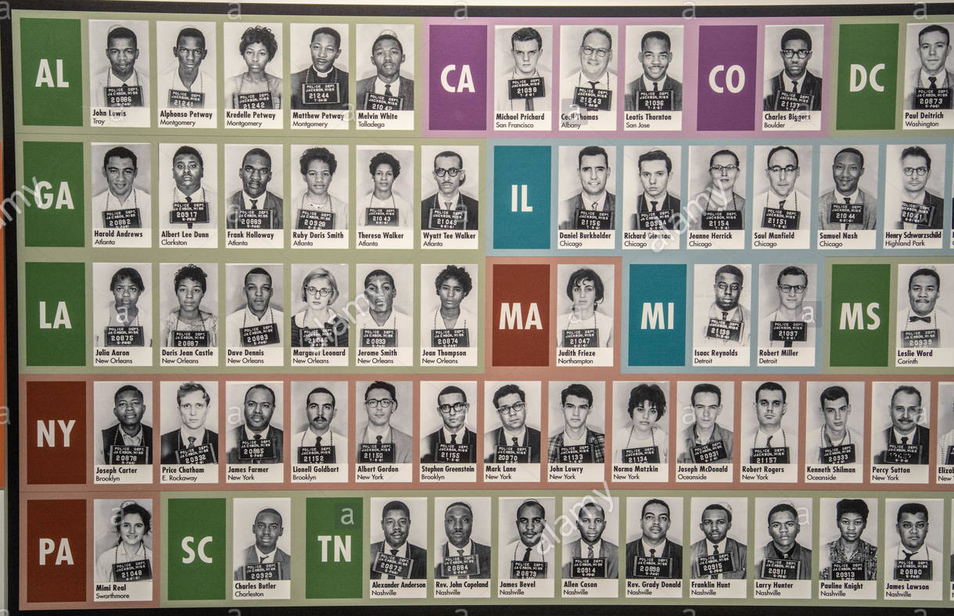
This workbook belongs to

Click or tap here to enter text.

Welcome to the Freedom Rides tour!
In today’s workshop, we are going to be taking you on a scavenger hunt back in time!

In 1961, Freedom Rides, groups of volunteers black and white, male and female, rode a Greyhound bus to Montgomery, AL in protest of segregation in public transportation. Students will visit this museum and learn about these courageous young people and the work they did to protest using non-violent methods.

We put together this handy workbook to guide your great hunt. In the following pages, you will find space for all the questions and tasks that you will come across during your scavenger hunt. Do not hesitate to ask any questions you might have along the way – and make sure you have a great time!

Let the Hunt Begin!

Table of Contents
Welcome to the Freedom Rides tour! 2
Helpful tools and tips 4
PART ONE: AREA DISCOVERY! 6
PART TWO: MY EXPERIENCE! 9

Helpful tools and tips
Below is a list of helpful tools and features that will make your great hunt a little easier.
Windows 10

Taking a screenshot
- Press Windows logo key + Shift + S to bring up the Snip and Sketch tool.
- Drag to outline the part of your screen you want to capture. To capture the entire screen, click the icon to the left of the “X.” To cancel the screen capture, press the Escape (Esc) key.
- In the window where you want to place the screen capture, press Ctrl + V to paste the image.

Seeing two windows at once
- Select the title bar of the window you want to snap.
- Drag it to the edge of your screen. An outline will appear to show where the window will snap to once you drop it.
- Drag it to the left or right side of your screen to snap it to the left or right half of the screen.
- If other windows are open, you can select one to fill the other half of the screen.
MacOS

Taking a screenshot
- Press Shift + Command + 4 and drag to outline the part of your screen you want to capture. To capture the entire screen, press Shift + Command + 3. To cancel the screen capture, press the Escape (Esc) key.
- If you see a thumbnail in the corner of your screen, click it to edit the screenshot. Or wait for the screenshot to save to your desktop.

Seeing two windows at once
If the steps below don't work, choose Apple menu > System Preferences, click Mission Control, and make sure that “Displays have separate spaces” is selected.
Method 1: MacOS Catalina
- Hover your pointer over the full-screen button in the upper-left corner of a window.
- Choose ”Tile Window to Left of Screen” or ”Tile Window to Right of Screen” from the menu.
Method 2: Older MacOS versions
- Click and hold the full-screen button in the upper-left corner of a window.
- As you hold the button, the window shrinks, and you can drag it to the left or right side of the screen.
- Release the button, then click a window on the other side of the screen to see both windows side by side.

PART ONE: AREA DISCOVERY!
In Area Discovery, you will need a good eye and some great virtual field trip skills to answer three trivia questions in each area. Follow along and pay attention to the text and videos to find the answers. The Teacher for the day will share Location Hints that will help guide you to the answer locations, so be sure to listen as you are exploring!

Click Here to Explore the Freedom Rides Museum
Question 1
On what year did Southern Stations have separate facilities for white and colored people?

Answer here!  Click or tap here to enter text. | Location hint!  First Photo

Question 2
On May 20, 1961 _______ ______ led a group of black and white SNCC members to test a court case that declared segregation in bus terminals unconstitutional?

Answer here!  Click or tap here to enter text. | Location hint!  Civil Rights Freedom Riders Plaque

Question 3
What route did the Freedom Rides take?

Answer here!  Click or tap here to enter text. | Location hint!  #6 Washington to Alabama Map

Question 4
From May 14-17 students in Nashville chose to participate in peaceful counter-protests. Why did they choose to do this?”

Answer here!  Click or tap here to enter text. | Location hint!  #10 May 14 -17 Nashville Movement

Question 5
When was the Student Non-Violent Coordinating Committee (SNCC) created?

Answer here!  Click or tap here to enter text. | Location hint!  #10 Nashville Movement May 14-17

Question 6
“On May 17-20, the Riders were arrested. What was their charge? How was the charge justified?”

Answer here!  Click or tap here to enter text. | Location hint!  #14 May 21-22 The Siege

Question 7
“Where was Parchman Prison located?

Answer here!  Click or tap here to enter text. | Location hint!  Reunion at Parchman Prison Farm

Question 8
What do you admire the most about the Freedom Riders? (in your opinion)

Answer here!  Click or tap here to enter text. | Location hint!  June July, August & September posters

Question 9
What’s the name of the woman in the picture and why was she arrested?

Answer here!  Click or tap here to enter text. | Location hint!  The fight for equality

Question 10
What story impacted you the most? (in your opinion)

Answer here!  Click or tap here to enter text. | Location hint!  Individual mugshots

Question 11
Is there a mugshot of a minor, someone that is young under the age of 18 – if so, what is their name?

Answer here!  Click or tap here to enter text. | Location hint!  Individual mugshots

PART TWO: MY EXPERIENCE!
Here’s your opportunity to do some free exploring and tell us all about your favorite section of the Freedom Rides Museum Experience. What impacted you the most? We want to know what you learned.

What impacted you the most?

Do you think we still face some of these issues?

