Fort Monroe & Milton House Museum

Workbook

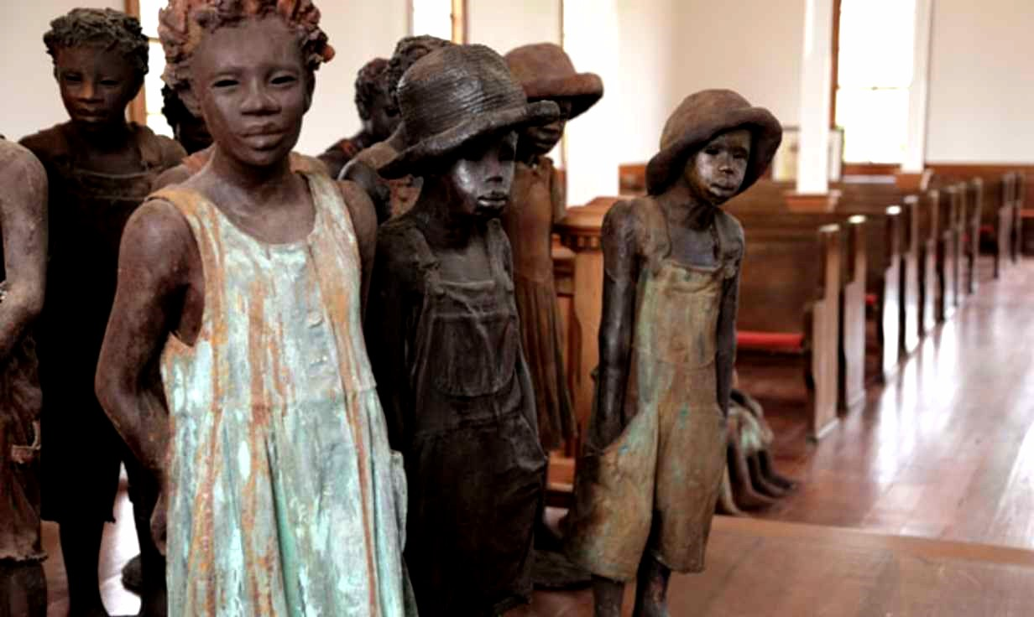
This workbook belongs to

Click or tap here to enter text.

Table of Contents
Helpful tools and tips 3
Retracing the Steps of Slavery from Enslavement to Emancipation tour! 5
PART ONE: AREA DISCOVERY! 6
Zone 2: Mapping Chesapeake 10 7
Welcome to the Milton House tour! 12
PART ONE: AREA DISCOVERY! 13

Helpful tools and tips
Below is a list of helpful tools and features that will make your great hunt a little easier.
Windows 10

Taking a screenshot
- Press Windows logo key + Shift + S to bring up the Snip and Sketch tool.
- Drag to outline the part of your screen you want to capture. To capture the entire screen, click the icon to the left of the “X.” To cancel the screen capture, press the Escape (Esc) key.
- In the window where you want to place the screen capture, press Ctrl + V to paste the image.

Seeing two windows at once
- Select the title bar of the window you want to snap.
- Drag it to the edge of your screen. An outline will appear to show where the window will snap to once you drop it.
- Drag it to the left or right side of your screen to snap it to the left or right half of the screen.
- If other windows are open, you can select one to fill the other half of the screen.
MacOS

Taking a screenshot
- Press Shift + Command + 4 and drag to outline the part of your screen you want to capture. To capture the entire screen, press Shift + Command + 3. To cancel the screen capture, press the Escape (Esc) key.
- If you see a thumbnail in the corner of your screen, click it to edit the screenshot. Or wait for the screenshot to save to your desktop.

Seeing two windows at once
If the steps below don't work, choose Apple menu > System Preferences, click Mission Control, and make sure that “Displays have separate spaces” is selected.
Method 1: MacOS Catalina
- Hover your pointer over the full-screen button in the upper-left corner of a window.
- Choose ”Tile Window to Left of Screen” or ”Tile Window to Right of Screen” from the menu.
Method 2: Older MacOS versions
- Click and hold the full-screen button in the upper-left corner of a window.
- As you hold the button, the window shrinks, and you can drag it to the left or right side of the screen.
- Release the button, then click a window on the other side of the screen to see both windows side by side.

Retracing the Steps of Slavery from Enslavement to Emancipation tour!
In today’s workshop, we are going to be taking you on a scavenger hunt back in time!

Students will learn about the diverse storyline that Fort Monroe National Monument has in America's history, part of which marked the location of the first arrival enslaved Africans in English North America, but later marked the beginning of the end of slavery in the U.S. -- the reason Fort Monroe is also now called "Freedom's Fortress."

We put together this handy workbook to guide your great hunt. In the following pages, you will find space for all the questions and tasks that you will come across during your scavenger hunt. Do not hesitate to ask any questions you might have along the way – and make sure you have a great time!

Let the Hunt Begin!

PART ONE: AREA DISCOVERY!
In Area Discovery, you will need a good eye and some great virtual field trip skills to answer three trivia questions in each area. Follow along and pay attention to the text and videos to find the answers. The Teacher for the day will share Location Hints that will help guide you to the answer locations, so be sure to listen as you are exploring!

Click Here to Explore

Zone 1: The Originals

Question 1
What was the name of the Colonist who spent a week in the Kecoughtan Village?
Answer here!  Click or tap here to enter text. | Location hint!  The Originals Exhibits

Question 2
After learning about Capt. Smith what do you think this quote means?
Answer here!  Click or tap here to enter text. | Location hint!  Zone 1 – Personal Opinion

Zone 2: Mapping Chesapeake 10

Question 3
Chesapeake region is what states today
Answer here!  Click or tap here to enter text. | Location hint!  Mapping the Chesapeake

Question 4
What was Captain John Smiths Goal when making his map?
Answer here!  Click or tap here to enter text. | Location hint!  Demand for Slave Labor Grows Exhibit

Zone 3: American Indians of Eastern Virginia

Question 5
Why was Trading important?
Answer here!  Click or tap here to enter text. | Location hint!  American Indians of Eastern Virginia

Question 6
What was the name of the 1606 English merchant join-stock company?
Answer here!  Click or tap here to enter text. | Location hint!  American Indians of Eastern Virginia

Question 7
What renowned skill dd the Africans bring with them to American?
Answer here!  Click or tap here to enter text. | Location hint!  American Indians of Eastern Virginia

Demand for slaves grow

Question 8
By 1750 Africans made up what percent of the colony’s?
Answer here!  Click or tap here to enter text. | Location hint!  Demand for Slaves Grow

Virginia Laws support Slavery

Question 9
Do any of these surprise you? Which Law is the most shocking to you? Let’s discuss in the chat
Answer here!  Click or tap here to enter text. | Location hint!  Virginia Laws Support Slavery

An African Child is born

Question 10
The bullet tells us that Anthony & Isabella were indentured servants. What do you think the difference is between indentured servants and slaves?
Answer here!  Click or tap here to enter text. | Location hint!  An African Child is born

First enslaved arrive

Question 11
At the beginning we watched a video and reflected on the first Enslaved African being brought into this country. Once they arrived here what do you think was going through their minds, being indentured servants and being sold for food?
Answer here!  Click or tap here to enter text. | Location hint!  First Enslaved Arrive

Enormous Undertaking & Brick by Brick

Question 12
What nickname was Ft. Monroe given because of its strategic location?
Answer here!  Click or tap here to enter text. | Location hint!  Enormous Undertaking & Brick by brick

Question 13
What was the of the Delaware Slave Holder contracted to make the bricks that built Ft Monroe?
Answer here!  Click or tap here to enter text. | Location hint!  Enormous Undertaking & Brick by brick

Benjamin Butler, Daring voyage and Refuge 10 min

Question 14
What was the name of the law that required US Army to return runaway slaves?
Answer here!  Click or tap here to enter text. | Location hint!  Benjamin Butler

Question 15
How important was General Butler’s contraband of war decision?
Answer here!  Click or tap here to enter text. | Location hint!  Benjamin Butler

Provind Relief / Rising from ashes

Question 16
What was the goal of the American Missionary Association?
Answer here!  Click or tap here to enter text. | Location hint!  Providing Relief/Rising From ashes

Question 17
Quote Reflection: It is the place that marls both the beginning and the beginning of the end of slavery? What did Gerri Hollins mean by this?
Answer here!  Click or tap here to enter text. | Location hint!  Providing Relief/Rising From ashes

Hampton and Booker T.

Question 18
Samuel Chapman and Booker T. Washington both started what?
Answer here!  Click or tap here to enter text. | Location hint!  Statue Marks

Statue Marks

Question 19
What were the names of the 3 enslaved men that escaped to Ft. Monroe?
Answer here!  Click or tap here to enter text. | Location hint!  Statue Marks

Question 20
What might they have seen once arriving at Fort Monroe?
Answer here!  Click or tap here to enter text. | Location hint!  Share your opinion

Welcome to the Milton House tour!
In today’s workshop, we are going to be taking you on a scavenger hunt back in time!

The Milton House is an official site of the Underground Railroad, a network of secret routes and safe houses established during slavery and used by enslaved African Americans to escape into free states and Canada. Students will get to experience tunnels, caves a secret passage slaves used to get to freedom.

We put together this handy workbook to guide your great hunt. In the following pages, you will find space for all the questions and tasks that you will come across during your scavenger hunt. Do not hesitate to ask any questions you might have along the way – and make sure you have a great time!

Let the Hunt Begin!

PART ONE: AREA DISCOVERY!
In Area Discovery, you will need a good eye and some great virtual field trip skills to answer three trivia questions in each area. Follow along and pay attention to the text and videos to find the answers. The Teacher for the day will share Location Hints that will help guide you to the answer locations, so be sure to listen as you are exploring!

Click Here to Explore the Milton House

Zone 1

Question 1
Now Slavery was hard enough but can you imagine working being 8 months pregnant or doing manual labor. Think about going outside in the heat of Summer, its 110 degrees and you must do manual labor outside, for 12+ Hours, while holding a child….DO you think you would have been strong enough to handle what they had to endure?

Answer here!  Click or tap here to enter text. | Location hint!  Zone 1- Share your opinion

Zone 2 – Harsh Life

Question 2
The slaves had jobs such as planting, cultivating, and harvesting crops cooking and cleaning. However, today there are many people who find joy in these same tasks. What do you think was the difference?
Answer here!  Click or tap here to enter text. | Location hint!  Zone 2 - Harsh Life

Question 3
What methods did slave owners use to ensure their Runaway slaves were captured and returned?
Answer here!  Click or tap here to enter text. | Location hint!  Zone 2 – Harsh Life

Question 4
What were some of the punishments that happened to returned slaves?
Answer here!  Click or tap here to enter text. | Location hint!  Zone 2 – Harsh Life

Family III

Question 5
What were reasons that an enslaved person could be sold?
Answer here!  Click or tap here to enter text. | Location hint!  Family III

Zone 4 – On the run

Question 6
What were the dreams and desired of those seeking Freedom?
Answer here!  Click or tap here to enter text. | Location hint!  Zone 4 – On the run

Zone 5 – Fugitive Slavery

Question 7
How did the Fugitive Slave act of 1854 make seeking Freedom dangerous?
Answer here!  Click or tap here to enter text. | Location hint!  Zone 5 – Fugitive Slavery

Zone Underground and North Star

Question 8
The abolitionist movement was an organized effort to end the practice of slavery in the United States. There are many Abolitionist Black and white. Can you name a few?
Answer here!  Click or tap here to enter text. | Location hint!  Zone Underground Railroad

Zone North Star

Question 9
Name a conductor of the Underground Railroad that helped many freedom seekers right their northern destination.
Answer here!  Click or tap here to enter text. | Location hint!  Zone North Star

Question 10
What is the name of the star that slaves used to help them escape?
Answer here!  Click or tap here to enter text. | Location hint!  Zone North Star

Milton House Outside

Question 11
Similar to today’s Civil Rights movement and even today’s social justice movement, we see here with the Goodrich’s the important part Ally’s play in getting justice for all. What do you think an ally is? Why was it important to have them during slavery and why is it important to have them now?
Answer here!  Click or tap here to enter text. | Location hint!  Milton House Outside

How did slaves get to Milton House

Question 12
What would Ense do to help hide the slaves?
Answer here!  Click or tap here to enter text. | Location hint!  How did slaves get to Milton House

Question 13
Where did the freedom seekers taken once at the Milton house?
Answer here!  Click or tap here to enter text. | Location hint!  How did slaves get to Milton House

Question 14
What was the actual purpose of the cellar?
Answer here!  Click or tap here to enter text. | Location hint!  How did slaves get to Milton House

