Title: How does a Total Solar Eclipse Affect Air Temperature?
Student Sheet
- Examine: Here is a diagram showing how the Moon’s shadow hits Earth. Locations on Earth that are in the darkest part of the shadow, known as the umbra, experience a total solar eclipse. Locations on Earth that are in the lighter parts of the shadow, known as the penumbra, experience a partial solar eclipse.
This diagram is not to scale. Nothing in the diagram is the correct scale. It is designed to emphasize the umbra and penumbra.
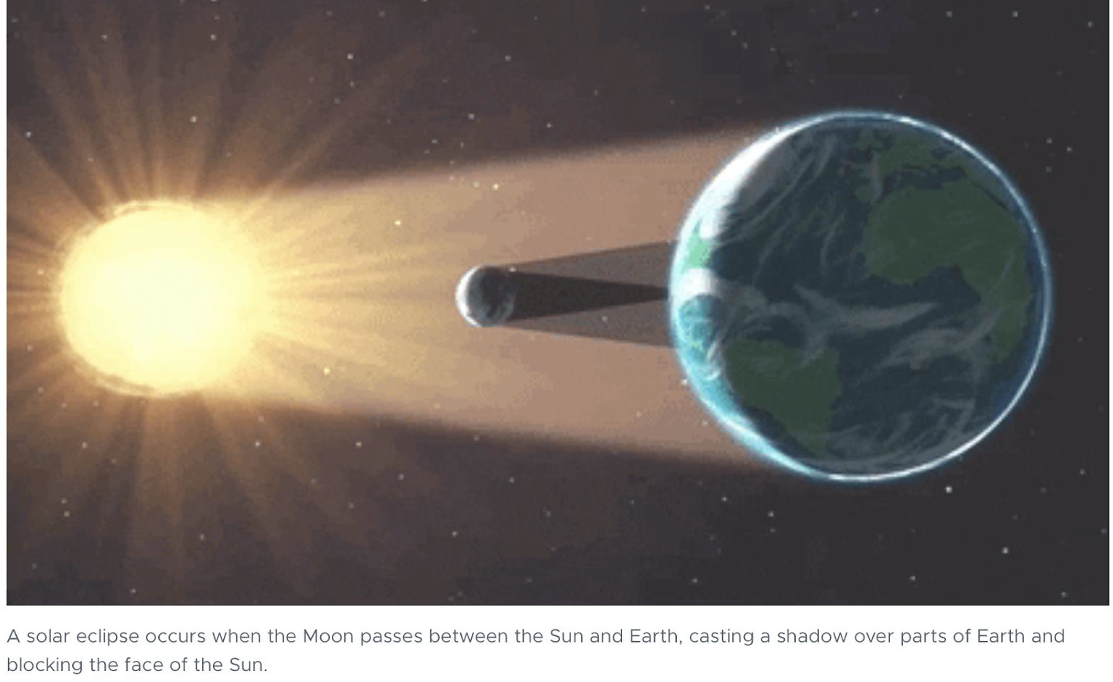
Eclipse Shadow, Image Credit; NASA, https://mynasadata.larc.nasa.gov/sites/default/files/inline-images/Eclipse%20Shadow.png
- Watch: This visualization shows how the Moon's shadow dramatically affects air temperature, This shows a total solar eclipse that was in the continental United States. It was on August 21, 2017. As the umbra passes overhead, the temperature drops by several degrees.
In this visualization, the partial solar eclipse is represented by the light gray, outer circle (penumbra). Areas in the light penumbra experienced a partial solar eclipse. It hit the west coast of the continental US at approximately 10:00 am Pacific Standard Time.
The dark inner circle is the umbra. It represents the total solar eclipse. It reached Oregon approximately 15 minutes later. The Moon’s shadow took approximately four hours to traverse the continental US.
GLOBE Air Temperature with Eclipse Shadow 2017 | Video Length 0:41 | https://www.youtube.com/watch?v=c1NsClv1Du4
- Analyze:
  - Approximately how many degrees does air temperature drop during the eclipse? Hint: look at the legend for the temperatures for the colors.
    - In the penumbra?

    - In the umbra?

  - Do locations experiencing the total solar eclipse have greater temperature variations than locations experiencing the partial solar eclipse? Record your observations.

  - Aside from the Moon’s shadow, what other variables would affect the air temperature during this four-hour period? Record your observations.

- Make a prediction: How do you think plants and animals would behave during a total solar eclipse?

