**Oak Park School District**

Winter 2022

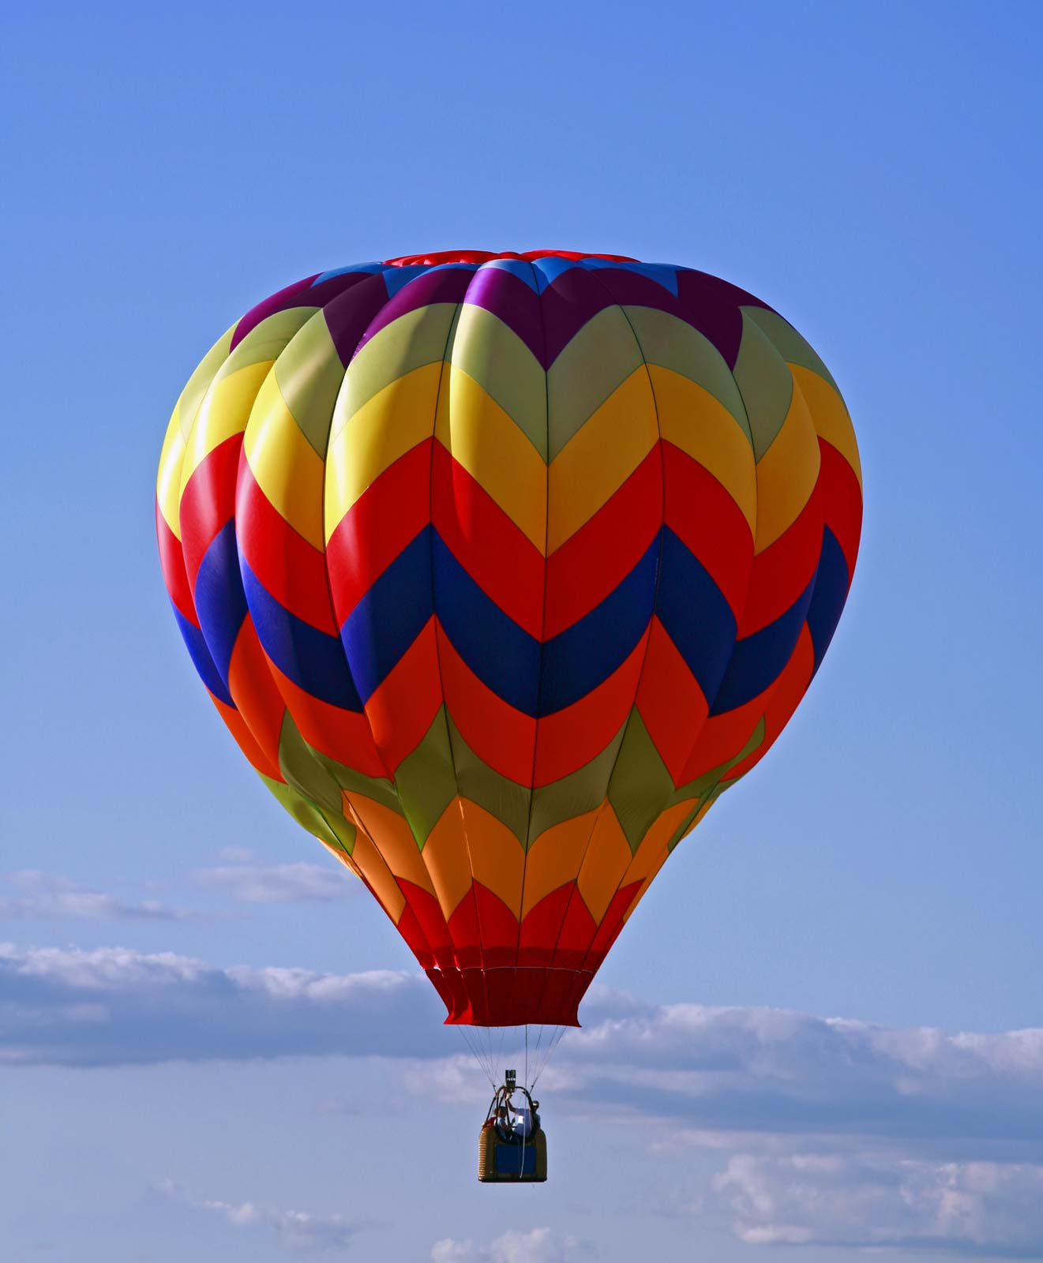

**Hoffman Planetarium**

*1st Grade Activity Guide*

**Earth Science**

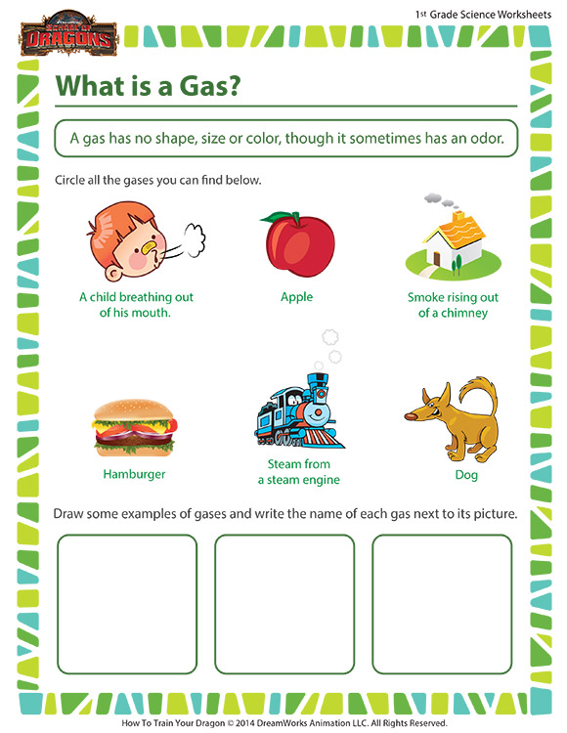

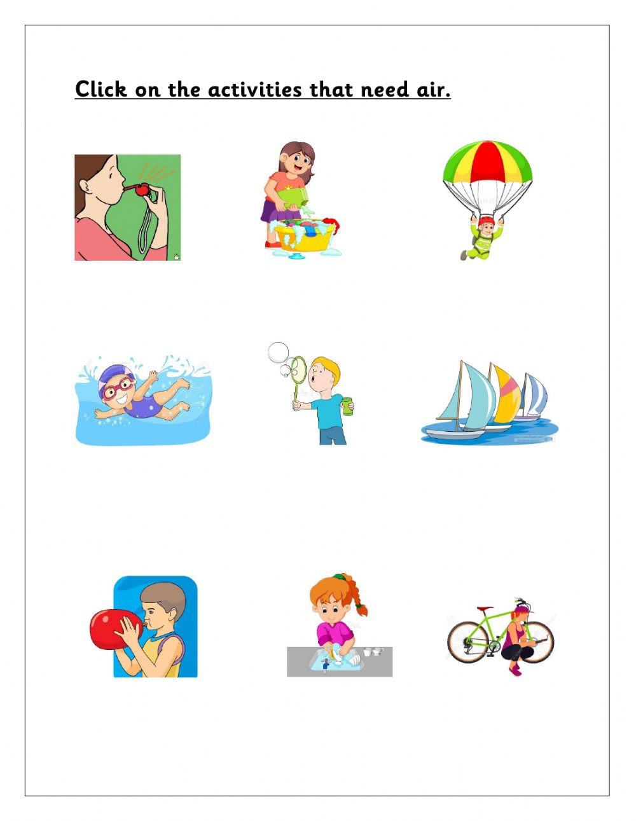

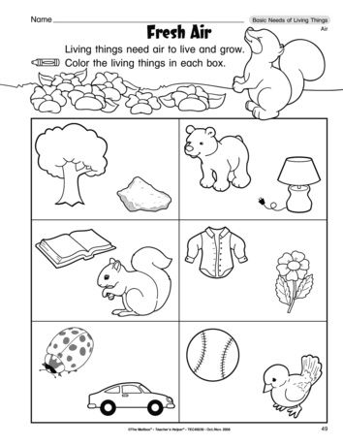

**Hot Air Balloon Maze**

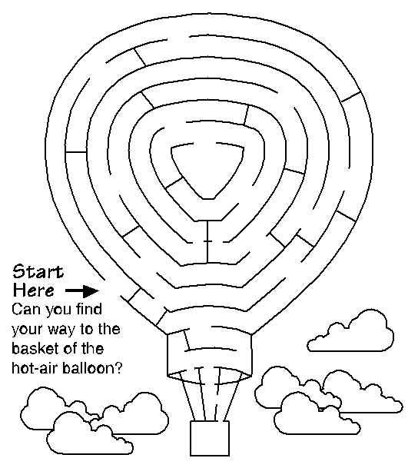

**Four Seasons**

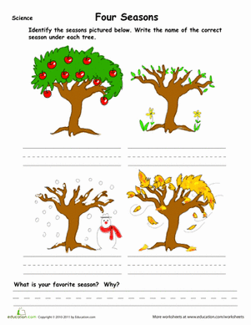Identify the Seasons pictured below. Write the name of the correct Season under each tree.

Which Season is your favorite? Explain why.

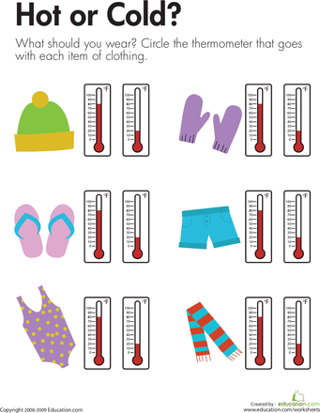

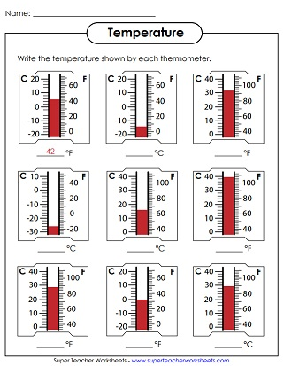

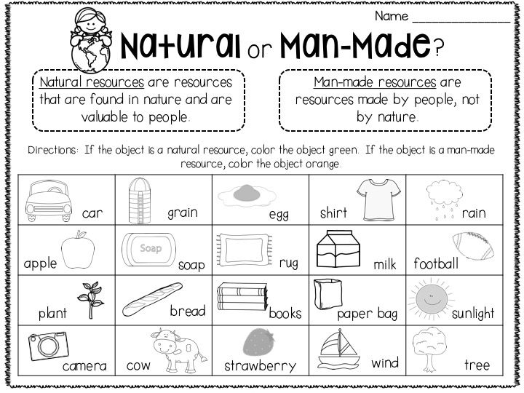

**Animals in the Winter**

Use the spaces below to show which animals hibernate and which animals migrate. You can cut the images out in put them in the right column.

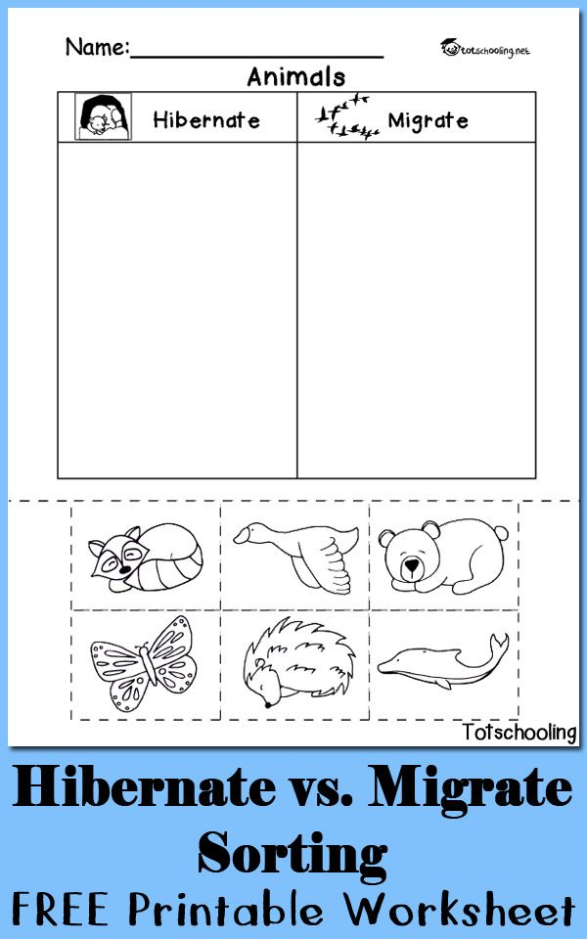

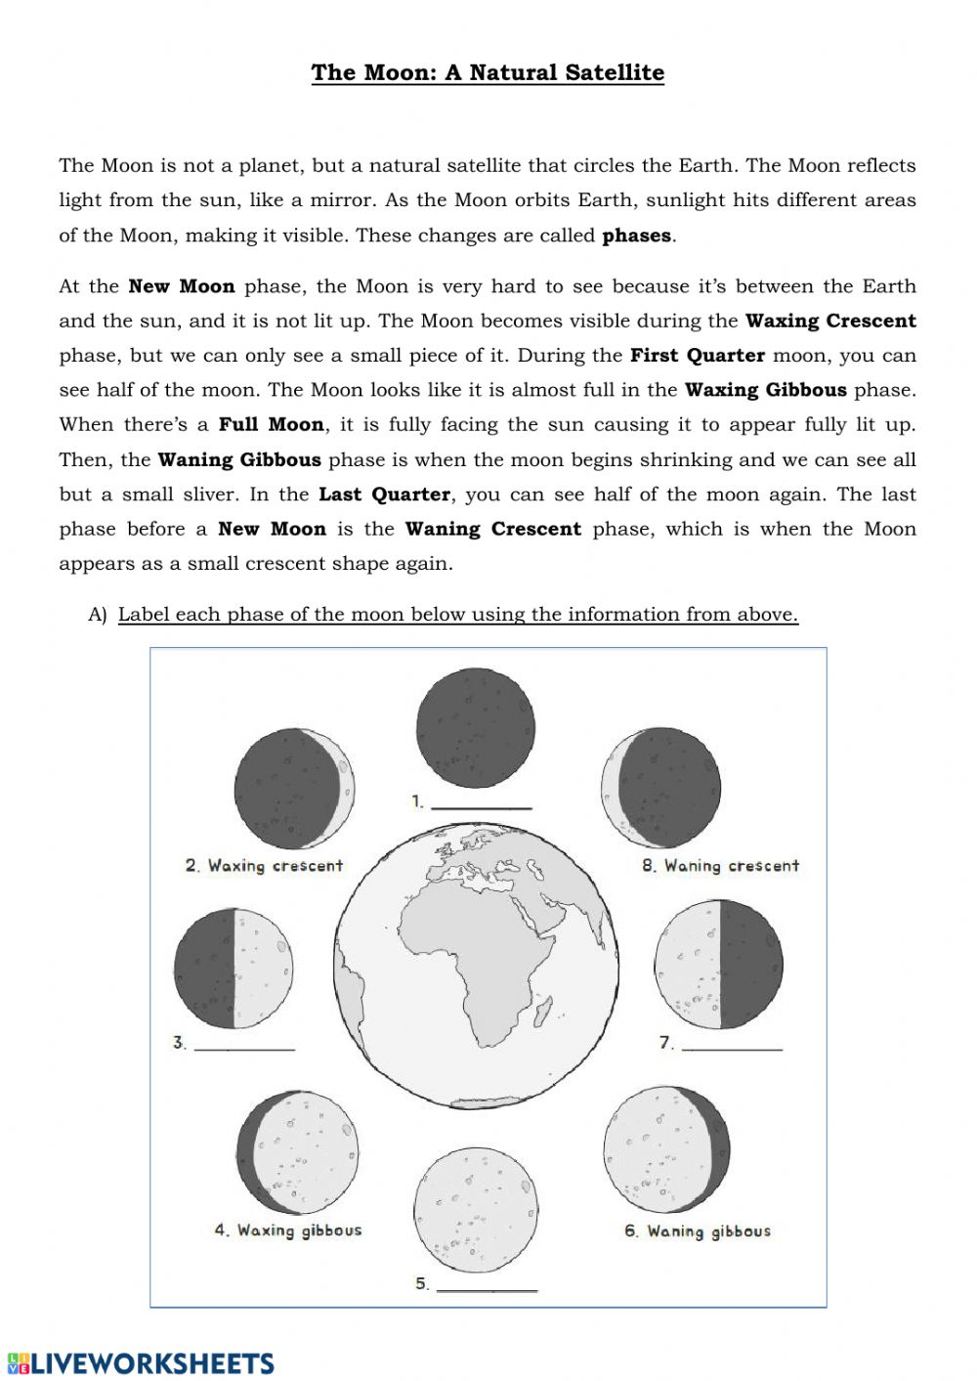

The Moon - Phases

